Bridget – Level 2 EPQ

Why is homework necessary and what impact does it have on secondary school students?

- Project proposal
- Project log
- Essay
- Sources

Essay

Why is homework necessary and what impact does it have on secondary school students?

- Introduction

Homework: a controversial topic regularly debated by students, parents, and teachers with varied opinions on its benefits or necessity. I chose to do further research on this topic for my Extended Project Qualification (EPQ) as I believe it is an important topic given that despite the different views continues to be a fundamental part of student life.

Like many students, I have an aversion to homework and often wonder whether there are any real benefits to doing homework. I find that it encroaches on my already limited free time and can cause havoc with sleep, happiness and stress levels, especially during exam season.

More recently homework became controversial due to the pandemic. Both educators and parents questioned the benefits of homework in the context of prolonged hours of screen time and isolation. Views on homework shifted as most schools decided to set substantially less homework during this time. Other external factors also contributed to the reduction of homework such as screen time and mental health, but lockdown forced educators to rethink teaching and traditional homework setting. It was important to consider the impact homework has not just on the overall holistic educational experience students receive but its potential long-term impacts on student happiness, mental health and well-being.

While researching the topic, it became apparent that the topic was more complex than my original simplistic view. There seems to be a great deal of support for the setting of homework, but the benefits vary depending on the age group, with only a handful of protagonists against it. There is also a growing trend to re-evaluate the type of homework set to ensure its effectiveness and relevance.

- Methodology
Initially I considered a different topic but after a few weeks landed on the topic of homework and how it affects secondary school students with the help of my supervisor. I felt drawn to this topic because I felt it is important and relevant. Further, if it is accepted that homework is necessary, what measures can be taken to ensure that it has positive impacts and remains an effective learning tool.

To develop my own understanding of the topic and form a considered view, I needed to understand the broad spectrum of views from academics, researchers, teachers, and students. My primary sources are internet based and my secondary source in support of students’ view is based on a student survey of students in Year 7 to Year 13 conducted at my school.

- Literature review

The primary sources are predominantly based on articles I found on the internet, by identifying existing research and theories on the topic which included scholarly articles by educators and research organisations, and specialist educators from primary and secondary schools in the United Kingdom and the United States.

- Survey

For a secondary source, it was important to be objective and understand other students’ perspectives other than my own. A simple way of collecting a broad range of student views would be through a survey. I conducted a survey from a sample group of 171 students who were my peers and from other year groups at my school from Year 7 through to Year 11. The reason I sampled students at my own school was in part due to practicality, as they were easily accessible and it was efficient use of my time but more importantly, the sample group had the same access to teachers and resources, and therefore it was likely that there would be a uniform approach to the setting of homework by teachers at the same school.

To elicit relevant data from the survey, the questions had to be meaningful. Several questions were discussed with my supervisor, EPQ partner and Dr. Mellor, before narrowing down to seven questions. The questionnaire asked about the volume of homework the student received, what type of homework they received, how it affected their sleep and stress levels and whether they thought homework was helpful. The survey data provided some useful and some unexpected insights, which are discussed below.

- What is homework and is it necessary?

- Definition of homework

According the Durrington Research School, Cooper’s (1989) definition of homework is the most used: homework is any task given to student to be completed outside of usual school hours. It may come in many forms such as lesson task completion, preparing for future tasks or assessment revision. This aligns with the definition of the term given by the Education Endowment Foundation (EEF) in the Teaching and Learning Toolkit.

The definition is broad; “any task” and “completed outside of school”. These are relevant elements discussed below.

- Consolidates learning

Homework can help students consolidate knowledge on the lesson work and aids long-term retention. There is extensive research that supports the fact that homework can have a positive effect if (i) it reinforces something already learnt and (ii) does not take long and consolidates knowledge. The homework set should not be anything new. Long complex open-ended homework should be avoided and replaced with short frequent tasks closely monitored by teachers. Duration and complexity being the key qualifiers.
Dabell an Ofsted inspector and respected teacher further qualified his findings by stating that the benefit is greater to secondary students than primary school students, who should be set no homework at all. To get the most out of homework, it should reinforce something already learnt. Complex open-ended homework is often completed least effectively, whereas short, frequent homework, closely monitored by teachers is more likely to have more impact.

- Reduces exam cramming

Exams are a part of student life and revising for multiple subjects all at once is challenging especially with national exams where some students have 10 or more subjects they need to revise for. Instead, homework that is set as revision of more recent and past topics can help students to revise more frequently in more ‘bite-sized’ chunks. Revision tasks for homework can help active recall and transfer the knowledge to long term memory. The more frequently that students recall knowledge the easier it becomes and the more deeply that they understand the topic. This helps with exam preparation as they will find it easier to recall knowledge without cramming the night before.

- Identification of learning gaps

Homework can be key in allowing students to identify gaps in their knowledge as they get older, they become more responsible for the homework and their learning. Having work that has been marked by a teacher can help the student to go back and revise the topic or if needed they can ask a teacher for help. This reduces cramming before tests and overall will reduce stress as they are only revising topics that they know rather than teaching themselves a topic that they don’t understand.

- Impact of homework
There are both negative and positive impacts of homework.
- Positives
Based on the Survey, a majority of students (44.4%) agreed that homework is helpful. From primary sources there are several positive impacts which include accelerating learning and promoting independent learning and responsibility.
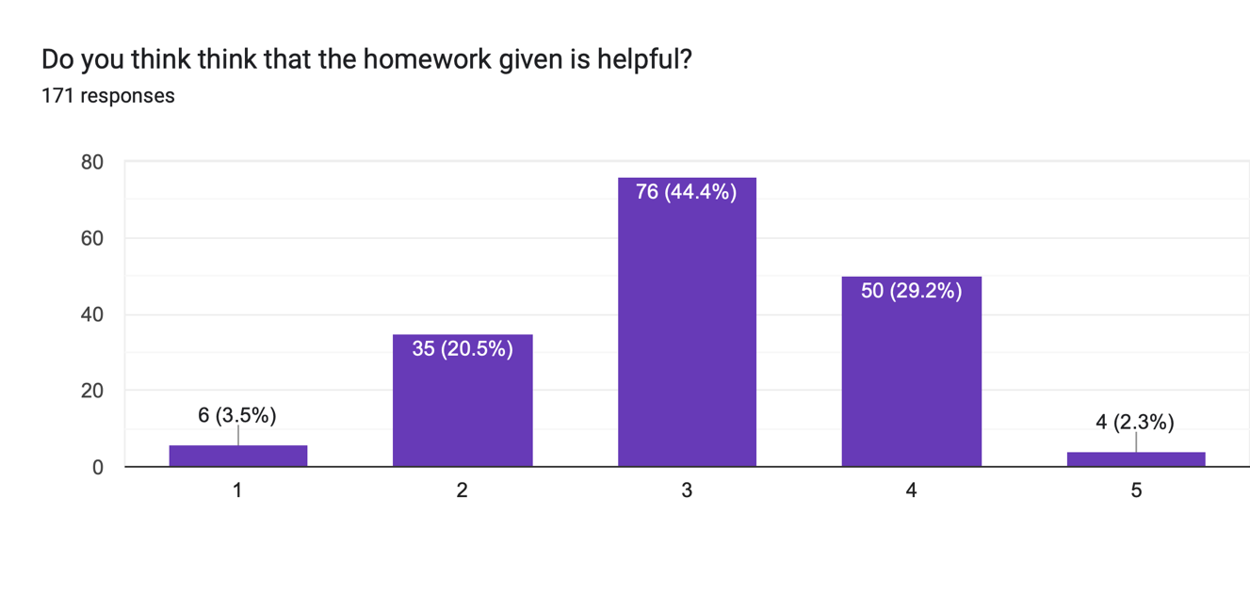
- Accelerates learning
Primary sources support that homework accelerates learning. Homework has positive effects if done correctly and can have a significant impact on the students learning. The EEF toolkit (which is an industry standard) on homework listed key findings which included:
- Evidence shows the positive impact of homework on average is five months additional progress (however, this depends on what year you are in).
- Some pupils don’t have quiet space to learn, and schools should adopt homework club
- Homework linked to classroom work tends to be more effective and stressed the importance of making the purpose of homework clear to pupils for them to fully engage and benefit from it.
- Evidence suggests that the quality of the task is more important than the quantity and how homework relates to learning during normal school time is very important.
- Promotes independent learning and responsibility

Homework is an important tool for teaching self-discipline and responsibility. It teaches students to manage their time around other commitments, be responsible for the completion of the task within a due date. These are essential life skills that help students become organised adults enabling a smooth transition into university and working life.

Based on extensive evidence, the concept of ‘metacognition and self-regulation’ was rated by the EEF Toolkit as high impact for very low cost. It recommends metacognition strategies for teachers to help students to think about their own learning more explicitly by teaching students to set their own goals, monitor and evaluate their own academic progress. It requires teachers to teach metacognitive strategies through seven step model – activating prior knowledge, explicit instruction, learned strategy and memorisation, guided ‘scaffolding’ practice, independent practice ‘removing the scaffolding’ and structured reflection. These appear to be complex steps to successfully implement in any classroom.

- Negatives

Negative impacts of homework include sleep deprivation, lack of free time, stress and exacerbation of social inequalities.

- Sleep deprivation
Based on the Survey, a majority of students lost some sleep due to homework (66.6%).
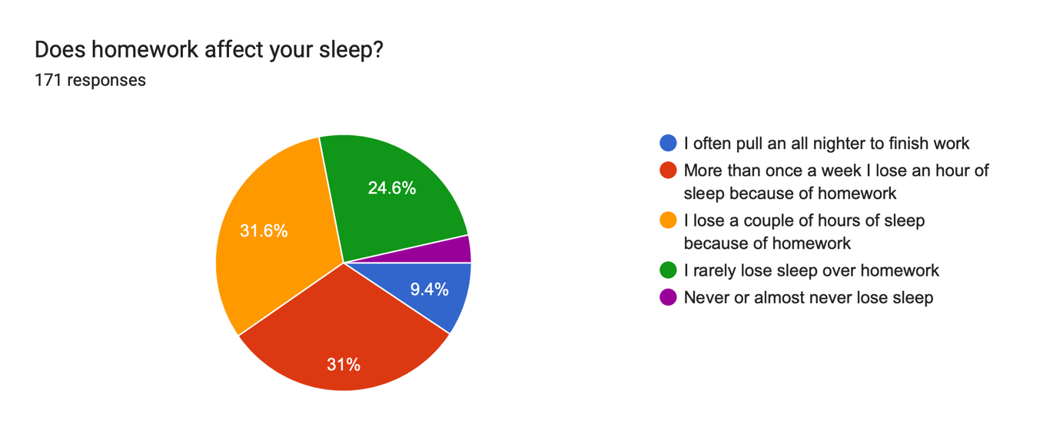
Sleep loss can have the biggest impact on the students' mental and physical health although many factors can contribute to it such as volume of homework, use of screens, caffeine intake and extracurriculars. Nine hours of sleep is ideal for a teenager going through puberty, but this is not achievable with the volume of work that students receive and the demands of daily life.

The most beneficial sleep received is earlier in the night from 10 pm-3am. This non-REM sleep is restorative and if students are having to go to sleep much later and then waking up later in the day, they receive fewer hours of this sleep and lighter REM sleep. The more hours of sleep that a teenager loses, the more likely they are to use alcohol and drugs as long-term sleep deprivation can affect impulse decision-making. There is also a correlation between sleep deprivation and teenage depression and anxiety. According to a study undertaken by the University of Arkansas, students were more likely to have increased feelings of sadness and hopelessness with each hour of sleep that they lose. Sleep deprivation can cause teenagers' already emotional state to become more extreme and affects the way that the brain's emotional regulation circuit functions.

- Reduced free time

As the volume of homework increases for students as the progress through school, there is less free time. Secondary students spend a lot of outside school time completing homework which is particularly heightened when students’ progress to sixth form and there is added pressure to complete university applications with personal statements that include numerous achievements and extracurricular activities, free time becomes even more difficult to find.

- Stress, physical and mental health issues

According to the Survey, 42.7% of students surveyed agreed that homework contributed to their stress levels.

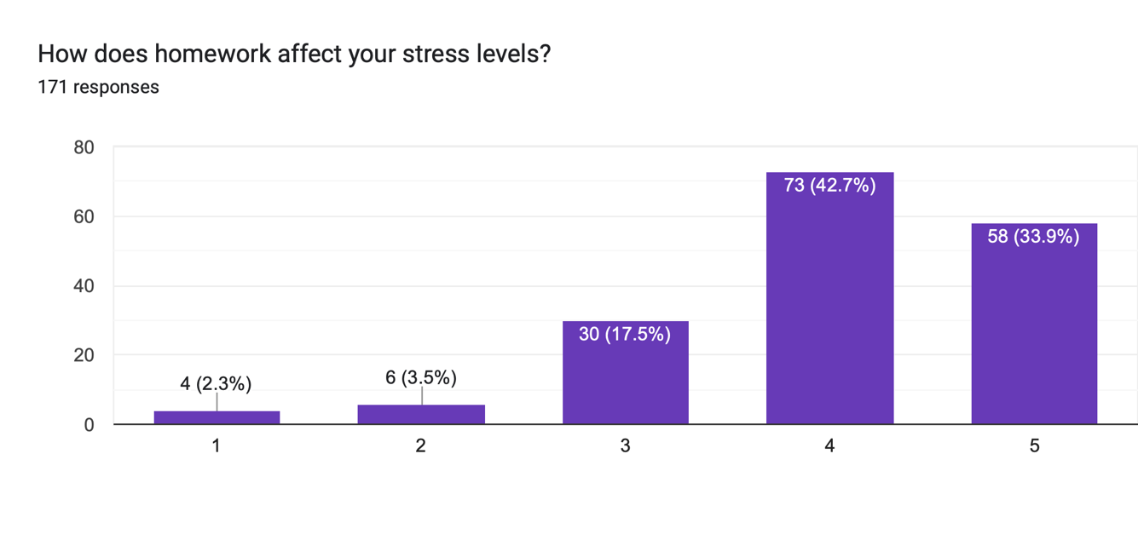
A Stanford researcher found that students in high-achieving communities who spend too much time on homework experience greater stress, physical health problems, exhaustion, lack of balance and even alienation from society. According to a Senior Lecturer at Stanford Graduate School of Education, homework had negative effects on student well-being and behavioural engagement based on survey data from 10 high-performing high schools.

Mental health issues have become increasingly important issue for schools and educators, particularly heightened during lockdown.

Homework can be a cause of stress for students for several reasons. These include the expectations of teachers for higher standard completed homework or failure to complete the set homework within the allotted time frame which places undue pressure on students’ sleep or free time and encroaches into valuable family time causing angst and frustration for not only students but parents alike.

What does become obvious is that there is no standardised answer on the precise impact homework has on one student over another. Whilst some students thrive on completing homework and therefore achieve improved exam results because of time and effort spent on homework, other students may have a negative experience finding homework tasks long and overchallenging, which results in feelings of failure and falling short of teacher and parent expectations thereby causing detrimental effect to their mental health.

- Exacerbates social inequality

Online learning during the pandemic highlighted the glaring gap between state and private schools, and how homework may be a lesser priority for those in lower socio-economic backgrounds.

The definition of homework includes work that is completed outside of school. However, not everyone has a quiet place to complete their homework with some students having to overcome greater hurdles due to their socio-economic backgrounds. Students in low-income households are less likely to have parental support to help with homework and care of younger siblings may also be an intervening factor or supporting their family with an income from a part-time job.

Unfortunately, the pandemic further exacerbated social inequality because students at state schools did not have the resources to easily transition to online learning, unlike private schools which were able to transition to online learning more easily. Parents in low-income families were more likely to working one or more jobs and would not be present to provide support for their children and access to laptops or internet availability may be prohibitive. Whilst the government sought to remedy this by providing free 4G WIFI routers and computers to low-income households, there was no supporting infrastructure connecting student home learning to school teaching platforms. Schools needed assistance to transition to online learning and teachers to be trained and sufficiently equipped to adopt to teach online.
The pandemic further exacerbated social inequality as those who were at state schools did not have access to counselling as mental health issues became more prevalent due to the lack of social contact. However, private school were more likely to have funding to facilitate counsellors for the students for someone to talk to.

- Displaces other activities

Time is limited and to balance competing demands within that timeframe means that not all activities can be pursued. To understand a student’s view on homework it is important to understand the different priorities that frame a secondary student’s time out of school. Some students struggle to balance the competing demands. This includes their obligations or commitments to their friends, family, or extracurricular pursuits. This is further exacerbated for secondary school students from low-income background as highlighted by lockdown, as such students often face additional challenges of a lack of a suitable home environment to undertake the homework and in some cases obligations to care for younger siblings after school when parents are out working, and those students face domestic pressures on top of school pressure.

- How can we optimise homework?

Evidence suggests that for homework to have a positive impact, it needs to be optimised by the setting of shorter, more frequent tasks to students who understand the purpose and this needs to be coupled by guidance and support provided by teachers. Quality prevails over quantity.

- Shorter, more frequent tasks

Evidence from the EEF toolkit suggests that the quality of the task is more important than the quantity and how homework needs to relate to learning during normal school time.
In the most effective examples, homework must be an integral part of learning rather than an add-on. The capacity of the working memory is limited but by grouping information or doing homework tasks through chunks makes it is more accessible and digestible. This also takes the pressure off students and the stigma around homework and makes doing the homework feel easier. This also means that tasks are more likely to be done during the week and this can increase free time to pursue other hobbies or to just wind down from the week.

- Close teacher monitoring, guidance and support

As referred to earlier, for homework to be meaningful and impactful, students need to understand its purpose and feedback is required to ensure purpose is achieved. Merely completing a piece of work and submitting by a deadline without the task being returned marked by the teacher is ineffective. To maximise any positive impact, it is important that students are provided with high quality feedback on their work. Teachers should not be setting homework for the sake of it but actively engaged with their students and tasking them with considered homework that is marked and feedback given.

- Manageable and challenging but not too difficult

The homework that is set should challenge the student. However, there should be no new learning involved instead the student should use what they learnt to think critically and extend their knowledge.

- Evaluation

My project objective was to find out whether homework is necessary and how it effects students, whether that is their mental health or free time or if it put unnecessary pressure on students from a young age. This project also meant that I had to manage my time which proved to be difficult as I was not hard enough on myself with the deadlines and milestones.

It comes as no surprise that the findings show that homework affected students both positively and negatively, from allowing students to have academic independence and responsibility to success in national exams such as GCSEs and A Levels. However, this does not mean that it comes without its disadvantages; homework can lead to stress and sleep deprivation. Both can negatively impact the student dramatically over time but if a balance is struck with free time and homework real success can be found.

I gathered information from a range of different sources from the ones recommended by teachers to the ones that I found on the Internet. I also used data from my school that I collected through a survey. This only backed up my findings further and helped me to gain perspective on homework at a highly affluent school. On the other hand, it also showed how students, particularly those in younger years believed that homework was unnecessary and too time consuming. However, due to lack of time management I was never able to conduct interviews from parents and teachers at my school. I think that this would have gained a deeper perspective into homework at my school and how the three different parties (parents, teachers and students) viewed homework.

The use of the data that I had collected gave further insight into the benefits of homework and although students did not like it and lost some sleep over it, they generally said that they thought that it was helpful to their learning (especially as the students moved up the school, they found that it became more meaningful). This project made me realise something that I never thought of; homework can exacerbate social inequality. Not having somewhere where homework can be done in a quiet and focused place can really affect a student’s experience with the homework, but it also means that they are not gaining the benefits from it. Having access to resources at home such as laptops or access the internet is becoming increasingly crucial in the way that homework is now being set. The student also having access to their parents to ask questions can have a crucial role in the benefits that students receive from homework.

I think that the advantage of researching a topic that I have personally experienced gave me a unique insight as I previously disliked homework as it always seemed pointless. I found that after doing research into the topic and from also my own independent revision that there are benefits to more frequent, shorter tasks and the value of feedback. On the other hand, it also showed me how homework can be ineffective. There is not much research to show how homework cannot be helpful to learning although there are a small few who disagree with it as a whole.

Overall, the EPQ produced was written to a fairly good standard. However, If I did this project again, I would be much stricter with my deadlines and set milestones. Without setting definite deadlines it was easy to not do work one week or fall behind on the timescale and this happened very quickly. I also think that whilst I completed the research I left the essay writing rather late which meant the writing was rushed. This made it more difficult during exam time as I had to completely stop my project to focus on studying and this disrupted the flow of writing. I would also have better communication with my supervisor and partner as my partner dropped out and did not tell me one week until the essay was due although this didn’t affect my project too much. I think to give more depth to the differing views I would have included cultural aspects to homework. From my own background, Eastern expectations on homework differ from Western expectations. Perhaps I also needed more negatives towards homework as the articles and data that I found predominantly favoured homework.

I think that this project helped me as a student as it gave me a way to practice a skill that I had never used which was writing longer essays. It taught me how it is essential to have a structure to map out the points to cover. This makes it easier to write it over the holidays and during school time as you can just add in your thoughts and write one small section at a time.

Now that I have completed the project, I have an insight and appreciation for the homework that I receive and how important it is to seek feedback rather than completing a homework task for the sake of it. It helps me to know that it will help me in the long run when I come back to revise for exams. This also taught me how key deadlines are and how to set more realistic ones as I originally thought that my project would be finished by May as I did not factor in other external factors such as sport and music as well as any schoolwork. I was also misguided as I did not think that it would be this difficult to pull together as I had no prior experience writing essayers longer than 1000 words and there was a steep learning curve. I think that I have gained a lot from doing this project and learnt skills that will help me later in my school and academic career.

Conclusion
In conclusion, fundamentally homework is necessary, but it must be optimised. It is the basis and form of the homework that needs to be carefully considered by teachers in not only setting the work but supporting the student with guidance and feedback. The purpose of the homework must also be understood by students to ensure the impact on them is positive and managed in the context of their overall mental health and well-being.
BIBLIOGRAPHY

- John Dabell (2019) “Getting the most out of homework” (www.sec-ed.co.uk/best practice/research-analysis-getting-the-most-out-of-homework/)

- Huntington Research School (2017) “Homework: What does the evidence say” (https://researchschool.org.uk/huntington/news/homework-what-does-the-evidence-say)

- Durrington Research School (2019) “What is the point of homework?” (https://researchschool.org.uk/durrington/news/what-is-the-point-of-homework)

- Heather Monroe (2018) “The importance of sleep for teen mental health” (https://health.usnews.com/health-care/for-better/articles/2018-07-02/the-importance-of-sleep-for-teen-mental-health)

- UK Government (2022) – “Education recovery in schools” (https://www.gov.uk/government/publications/education-recovery-in-schools-spring-2022/education-recovery-in-schools-spring-2022)

- Alfie Kohn (2012) – “Homework: An unnecessary evil…. “ (https://www.washingtonpost.com/news/answer-sheet/wp/2012/11/26/homework-an-unnecessary-evil-surprising-findings-from-new-research/)

- Joe Pinsker (2019) – “The Cult of Homework” (https://www.theatlantic.com/education/archive/2019/03/homework-research-how-much/585889/)

- Clifton B Parker (2014) – “Stanford research shows the pitfalls of homework” (https://news.stanford.edu/2014/03/10/too-much-homework-031014/)

Sources

Source 1

Title: Getting the most out of homework
URL: https://www.sec-ed.co.uk/best-practice/research-analysis-getting-the-most-out-of-homework/
What is it?
An article from a website made for a research school
Who produced it?
John Dabell is a teacher, teacher trainer and writer as well as being trained as an Ofsted inspector. He has been teaching for over 25 years and has written 10 books.
When was it produced?
It was produced by John Dabell on the 24^{th of} September 2019
What is the source telling you? The source tells us about how we can do homework as effective as possible. The article leans towards not having homework and it recommends that homework for primary school children is stopped completely. The article says that homework for primary school students has little to zero effect on their overall learning. Whereas homework for secondary students has a greater impact although homework tasks should not take long. If homework is set for students, it should be a short easy task such as reading over the notes from the lesson to consolidate knowledge rather than setting homework that can take one or two hours. Big projects where students must conduct their own research are not advised as the impact of homework is 5 months. Consolidating knowledge can help the students in the long run when revising for GCSE’s and A levels. This allows the students to have more free time to pursue what they want but also allowing their knowledge from school to be consolidated without stressing the teachers, students, and parents. Homework can add unnecessary stress to the students and puts pressure on teachers to mark this work. There has become this pressure for teachers to set homework when it really has not meaning; this article pushes schools to rethink their policy on homework and instead making their default policy to ‘no homework’.
What is its purpose?
To see if homework is necessary as it puts lots of pressure on students, parents, and teachers. The article is used by teachers and secondary schools and its purpose is to make sure that if homework is set it is as effective as possible. Homework is a part of school life, and it has been like this for many years. The article leans towards eradicating homework completely for primary schools as it burdens children from a young age. Homework for secondary schools can be effective if it is done correctly.
Is it reliable?
The website that the article is on is used by secondary schools all over the country. The article link was given to me by a teacher who recommended it.
How is it useful to answering the question?
It answers the question of the effectiveness of homework but also shows how homework can be useful if used correctly by both teachers and students.
What are the source’s limitations?
The source leans towards cutting homework out of the curriculum for children at primary schools and shortening the tasks for secondary school students making sure that they are done as effectively as possible.
Useful quotes:
- ‘Five to 10 minutes has the same effect of one to two hours. The worst thing you can do is give kids projects. The best thing you can do is to reinforce something you have already learnt.’
- ‘Homework in primary school has an effect of around zero. In high school it’s larger… which is why we need to get it right, not why we need to get rid of it’
Source 2

Title: Homework: What does the evidence say
URL: https://researchschool.org.uk/huntington/news/homework-what-does-the-evidence-say
What is it?
The article talks about how at their school they have changed homework or home learning as they now call it so that it has a purpose.
Who produced it?
It was produced by the Huntington Research School. The school uses the research that they conducted to further benefit their students learning.
When was is produced?
10th November 2017
What is the source telling you?
The source tells us how the school modified the traditional homework, changing it to home learning. The school changed their homework as they collected lots of data from surveys. They used the ‘EEF Toolkit (Secondary and Primary – not the crucial differences here: homework is much more effective with older children).’ Using this data, they were able to make sure that homework is as effective as possible at their school making a greater impact on the students. The new home learning system involves the practice or rehearsal of a topic that has already been learnt rather than any learning. They shouldn’t have to learn anything new for their home learning. They feel as though long complex open-ended homework questions should be avoided and instead replaced with more short frequent homework tasks that are closely monitored by teachers which are much more likely to have a greater impact. They created a ‘teachers scaffolding’ which is used by teachers to make homework more effective.
What is its purpose?
The purpose of the article is to show parents, teachers, and other schools how they have changed their homework to increase the effectiveness. This new system of home learning could be adopted by other schools. It emphasises how large complex questions have a very small effect of a student’s overall learning whereas short, more frequent homework pieces that are consolidating homework tasks are more effective and help to further a student’s knowledge. They also created a guide that the teachers should use which helps to work out if the homework they are setting is reliable.
Is it reliable?
I think that it is reliable as it is used by other schools and teachers that they could use in a classroom wherever they are. It was recommended to me by a teacher, so I believe that it is, but it was written by a school who have obviously been making sure that the homework that they are setting is as effective as possible.
How is it useful to answering the question?
It helps to answer the question as they have used reliable data that reflects the students from well-known institution.
What are the source’s limitations? It has a subconscious bias against homework and fails to mention how homework can be effective instead they talk about home learning which is similar just a different use of a student’s time.
Useful quotes:
- ‘Complex, open-ended homework is often completed least effectively; whereas, short frequent homework, closely monitored by teachers is more likely to have more impact.’

Source 3

Title: What is the point of homework?
URL: https://researchschool.org.uk/durrington/news/what-is-the-point-of-homework
What is it?
The article talks about the tradition of setting homework and how that is unforgivable instead it urges teachers to set homework that has meaning
Who produced it?
The Durrington Research School
When was it produced?
It was produces on the 29^{th of} June 2019
What is the source telling you?
The source tells us how students spend lots of time doing homework and so it should be as effective as possible. It shows that the impact of homework is a positive one if done correctly but we should try and add to its value by making sure that students are learning as much as possible through the tasks set. Though research has shown that homework has a positive effect on students’ knowledge by adding five months additional progress underneath there are varying impacts which depend on the type, quality and amount of homework that is set as well as the way that students complete the homework. The article also shows how some research can say that homework and academic success go hand in hand when they are not considering all factors. However, this article recommends that when homework is set the teachers should incorporate a metacognitive component; this is where the students must think about their thinking. This has shown to benefit older students and lower attaining pupils the most. This recommends that students receive 1-2 hours of homework a day for a secondary school student, and this is the optimum for a student’s learning. The homework that is set must be a two-way relationship. The students must trust the teachers and the teachers must trust that the students will try to do the homework to the best of their abilities. The work that is set by the teachers and completed by students must receive some sort of feedback.
What is its purpose?
Its purpose is to bring attention to the tradition of setting homework and to instead point schools and teachers to another direction of homework to ensure that students are receiving most of the homework that they receive. It encourages the use of metacognition for students’ homework which benefits them in the long run, but it also collates lots of data from well-known websites. Though it does disparage homework, they recommend that homework does have a positive effect if it is set with the correct meaning behind the work. Although some types of homework are truly there with no purpose, it is needed and will help learning so it will be staying.
It is reliable?
The article is on a website that teachers use, and it has lots of data collected by a reliable source.
How is it useful to answering the question?
It answers the question of what the point of homework is as well as recommending new components teachers can add into their homework tasks so that students are taking advantage of the work that they are doing after school.
What are the source’s limitations?
It has no opinion against homework and instead forms one throughout the article.
Useful quotes:
- ‘This evidence shows that the impact of homework, on average is five months’ additional progress.’
- ‘Th purpose of homework must be made clear for students if they are to fully engage and benefit from it.’
- ‘Broader evidence suggests that quality over quantity is important, and that students should receive some form of feedback on their homework if its impact is to be maximised.’

Source 4

Title: The Great British Homework debate 2021 – Is it necessary at primary school?
URL: https://thirdspacelearning.com/blog/homework-debate-disadvantages-benefits/
Who produced it?
It was written by Alexander Athienitis
When was it produced?
It was written last year
What is the source telling you?
The source has collated tweets from Rob Delaney and other teachers and education specialists who have followings on twitter they are trying to open the conversation to talking about homework and giving it to children who are in primary school
What is its purpose?
I think that the article is trying to bring awareness to homework being set for children in primary schools and you can see the comments from teachers and from parents regarding homework. Simon smith, who is a well-known head teacher believes that primary students shouldn’t have homework and instead they should read. Up until 2012 the department of education recommended that children aged 4-7 should have an hour of homework a week and children aged 7 -11 should have half an hour a day. Though this is not the policy that is in place now many schools still use this as a rule of thumb. A no homework policy only pleases a few people and sometimes it infuriates parents when their child doesn’t have enough homework but for others it is difficult because asking their parents to fill in the reading book is too much. Others believe that homework is a waste of time for children and instead want them to live and play with others; being more active and creative with their time.
Is it reliable?
The website uses the [roof from twitter and it can be used by teachers parents and students.
How is it useful to answering the question?
It shows how there is so much controversy around the topic of homework and whether it is useful for primary school students most evidence suggests no as it puts pressure on students from a young age and gives them no free time to explore what they want. It makes it very difficult but there is a balance as some teachers believe that no homework is necessary, but some parents don’t think that there is enough homework. It is difficult to balance it correctly to make sure that they students are fully learning but, some say that reading is all children need in primary school it allows them to learn in a fun interactive way without putting lots of pressure on them to be doing homework every night.
What are the sources limitations?
The source does not believe that homework is necessary for homework, but it does give reasons for both sides of the argument giving statistics
Useful quotes?
- ‘According to the Ofsted annual report on Parents Views more than a third of parents do not think that homework in primary schools is helpful to their children.’
- ‘The impact of homework is lot of but it also doesn’t cost much.’
- ‘They put it at a +2 months impact against a control of doing nothing. To put this into context, 1-to-1 tuition has a +5 months impact but it’s usually considered to be expensive.’

Source 5

Title: Homework is it worth the hassle?
URL: https://www.theguardian.com/teacher-network/2017/feb/07/homework-is-it-worth-the-hassle
Who produced it?
It was written for the Guardian, and it was written by Helen Silvester
When was it produced?
It was published on Tuesday 7 Feb 2017
What is the source telling you?
The source compares data from lots of people about homework and how homework can be made the most effective. Homework isn’t effective if the students are having to learn homework however, they are effective if they are consolidating the knowledge from the lesson as that is how we get information from our working memory into our long term memory. Generally, homework has a positive effect on the students and the amount of homework that they receive. Though students say that homework is a main cause of stress and limits their free time it does have a positive effect on consolidating knowledge
What is its purpose?
Its purpose is to show that homework does cause lots of stress it has data to support that it is worth the stress. There is a link to the volume of homework that students receive and their academic achievement. This further proves that though homework does put pressure on students and at times it can cause stress it has proven how it does have a positive outcome.
Is it reliable?
It was written for the Guardian, and it has reliable data from meta-analysis of studies and from a professor who has taught both secondary and primary and although his view is subjective he does show both sides of the argument and uses data to back up his view
How is it useful to answering the question?
It shows how homework is beneficial to the student however the volume that is set by teachers should be monitored as stress and volume of homework are related.

Source 6

Title: The importance of sleep for teen mental health
URL: https://health.usnews.com/health-care/for-better/articles/2018-07-02/the-importance-of-sleep-for-teen-mental-health
Who produced it?
It was written by Heather Monroe for the US news health
When was it produced?
It was written in 2018
What is the source telling you?
The source tells us that sleep loss can be detrimental to a teenagers mental and physical health. The ideal 9 hours of sleep are unfortunately unrealistic for a student who must attend school every day as well as the added stress of homework and extra-curriculars that happen before, during and after the school day. It becomes more difficult to sleep as there are many different factors that can affect this. For example, use of technology close to bedtime, caffeine intake and heavy workloads can make it difficult to set a normal bedtime routine. There is a clear link between sleep loss and depression and anxiety. Students are more likely to become depressed with each hour of sleep that is lost. Timing of sleep is incredibly important the most important sleep that we get is between 10pm and 3 am called restorative non-REM sleep so a student that sleeps at 3 will get fewer to no non-REM sleep and instead they will get fewer hours of restorative non-REM sleep even if they sleep late into the day. Instead, students should opt for earlier nights and earlier mornings. Lack of sleep can also cause students to become more impulse when making decisions and can increase the teens’ likelihood of using drugs and alcohol.
What is its purpose?
The purpose of this article is to bring awareness to the link between mental health and sleep deprivation and how school homework workload can affect this. In the long run this can cause greater damage to the student and their mental health. Sleep is very important in a teenage student’s life and in turn is very important for their mental health. Schools need to make a push for students to have more structured sleeping patterns.
Is it reliable?
The sources used for the article were all from studies conducted at universities and from surveys that had been sent out.
How is it useful to answering the question?
It shows how important sleep is and how homework can be one of the factors that affects it deeply. Teenage bodies without sleep cannot function fully and if the body sustains long periods without enough sleep it can have damaging effects on the student health.

Source 7

Title Education recovery in schools: spring 2022
URL: https://www.gov.uk/government/publications/education-recovery-in-schools-spring-2022/education-recovery-in-schools-spring-2022
Who produced it?
This was the report produced by the government explaining how they were taking steps to recover from the pandemic as learning had been set back.
What is the source telling you?
This source tells us how the government intends to improve learning as it suffered a lot during the pandemic according to Ofsted school reports. During the pandemic we saw a decline in pupils attendance rates and teachers due to the increased spread of COVID throughout schools and when the schools were shut down pupils had no way of contacting schools. The acceleration of students’ learning slowed significantly as the schools had to learn how to teach online. It was also more difficult for those who did not have access to Wi-Fi or a device. The pupils learning had been hindered and it continues to affect their knowledge and skills. Schools have also faced external barriers such as reaching the services for mental health. The report talks about the steps that schools are implementing to prepare the students who are taking national assessments such as filling in missed gaps and revision and retrieval tasks.
Is it reliable?
Yes, this report is useful as it is produced by the government who are the people who set the national curriculum. The report also uses data that has been collected by Ofsted who conducts the school checks every year.
How is it useful to answering the question?
The article highlights how now more than ever homework is necessary for students’ learning as they have lost lots of time in school due to the Pandemic. If students want to get their learning back to where it wants to be the schools must think about how they can do that most effectively.
Useful Quotes:
- ‘During Jan 2022, the pandemic continued to reduce pupils’ attendance in many schools’
- ‘Some schools said that the pandemic has influenced pupils’ subject choices at GCSE and A level’

Source 8

Title: Homework: An Unnecessary Evil? … Surprising Findings from New Research
URL: https://www.washingtonpost.com/news/answer-sheet/wp/2012/11/26/homework-an-unnecessary-evil-surprising-findings-from-new-research/
Who produced it? Alfie Kohn
When was it produced?
It was written in November 2012
What is the source telling you?
This article talks about how homework has no real effect on the students learning. The article also uses real life examples from teachers who decided to stop homework all together and they share their experiences with how their students reacted to the halt of homework being set from their teachers. The author questions whether it is necessary for students to have a ‘second-shift’ of homework after 6 or 7 hours at school. The article argues that homework is not necessary because it means that students are burdened with an extra workload, and it can become detrimental to their mental health. He writes about a Researcher Lyon and how he believes that homework should not be necessary. Lyon first tried this with his own class, not setting homework, he believed that this made it easier. He instead began his classes with an article that related to the topic that they would learn that day. This allowed his students to read over 100 college-level articles within the school year. The removal of homework, he said, made his students more interested in his lessons. They engaged more and with more free time they were able to go and research articles that interested them and bring them to class to discuss. The student’s curiosity increased as they had time to think about what they learnt. This forced Lyon to plan his lessons better because Homework could not be the overdraft of the lessons unfinished work. He had to make his lessons as efficient and engaging as possible. Other teachers took this approach with their students, and they found that engagement in lessons increased. Students felt more relaxed and ready to learn. However, Teachers found that it was more pressure for them as they still must cover the curriculum during the lessons. Without homework this is more difficult but without having to mark homework; they had more free time to plan lessons.
Is it reliable?
This article has data from many different teachers, and it was made into a book that many people read.
How is it useful in answering the question?
It shows how homework can be detrimental to a student’s health and how the students should have to come home from school and have a second shift of homework.

Source 9

Title: The Cult of Homework
URL: https://www.theatlantic.com/education/archive/2019/03/homework-research-how-much/585889/
Who wrote it?
Joe Pinsker
When was it produced?
March 28, 2019
What is the source telling you?
The article talks about how parents and teachers fall into the trap of setting homework for their students because it is what they had when they were children, and they were taught to believe that it is necessary. This article gives examples of places where schools have banned or phased out homework from their teaching because it became detrimental towards the health with no real benefit. For example, an affluent district in San Francisco decided to ban homework unless it was ‘meaningful’ and due dates directly after weekends and holidays. The students stress reduced substantially, and they performed just as well on standardized tests as before. It also talks about a teacher who teaches in a small town in Iowa phased out homework because the students were working 30-hour weeks or caring for younger siblings. So this reduced the stress in their lives and so this makes it easier for them to balance school and life more easily.
Is it reliable?
The article is written for a news article however it is biased against homework.
How useful is it to answering the question?
It shows the negative impact of homework on students and how it should be removed all together.

Source 10
URL: https://news.stanford.edu/2014/03/10/too-much-homework-031014/
Title: Stanford research shows pitfalls of homework
Who produced it?
Clifton B. Parker
When was it produced?
March 10, 2014
What is the source telling you?
The source is telling us how homework can be detrimental to a student’s health. Too much homework can affect kids negatively however if the correct balance is struck the students get the benefits of homework and can also have free time with family. Too much homework has been found to have negative effect and can be counterproductive. It can result in the student being isolated from society and can limit their free time to spend with friends or enjoying other pursuits. It can isolate the student so much so that they lose all learning of personal skills and how they can contribute to their local community.
Is it reliable?
I think that it is as it shows both sides of the argument and it is Stanford Report.
How is it useful to answering the question?
This article shows how homework can both positively and negatively affect the students and how a balance must be struck. Without it, students will learn at a slower rate but with too much the burden of homework will limit their learning.

Alfie Kohn Homework an unnecessary evil… (2012)
Durrington Research School: What is the point of homework: a look into the findings of systematic reviews regarding the value of homework (2019)
The EEF is an independent charity dedicated to breaking the link between family income and academic achievement. It does this by supporting schools to improve by teaching and learning through better use evidence. The EEF Teaching and Learning Toolkit is used by many secondary schools across the UK to improve homework practices.
Dabell, J Getting the most out of homework (2019)
Durrington Research School What is the point in homework? (2019)
Monroe, H The importance of sleep for teen mental health (2018)
Parker, C Stanford research shows pitfalls of homework (2014)
Joe Pinsker – The Cult of Homework (2019)
Govt – Education recovery in schools (Spring 2022)
Huntington Research School Homework what does the evidence say (2017)

