‘To what extent do students have a balanced view of British imperialism in India?’

By Diya

Edexcel Level 2 Higher Project (ZPJ20)

Table of Contents

Introduction ……………………………………………………………………………………………………………………………….. 3

Discussion ………………………………………………………………………………………………………………………………….. 4

Positive perceptions of the British in India …………………………………………………………………………. 4

Negative perceptions of the British in India ……………………………………………………………………….. 5

Today’s perspective ……………………………………………………………………………………………………………… 7

Gaps in the curriculum & an overdue apology …………………………………………………………………. 9

Conclusion ……………………………………………………………………………………………………………………………….. 13

Evaluation ………………………………………………………………………………………………………………………………… 14

Glossary …………………………………………………………………………………………………………………………………….. 16

Bibliography …………………………………………………………………………………………………………………………….. 17

Introduction

Britain has been involved in India for around 450 years, starting with the East India Company in 1600. Over time, it grew in strength, until India was referred to as the British Raj in 1858 lasting until India gained its independence in 1947. In this body of work, I will assess the different opinions on British imperialism in India, and assess ways to ensure students are taught about it in a more balanced, factual manner.

I am of Indian heritage, but through the research I have carried out for this extended project qualification, I was quite shocked to see that my knowledge of British involvement in India was superficial and anecdotal. Through interviews and discussions with classmates and teachers, I also realised most of them were in the same position, and that their views on colonialism (especially in India) were more negative compared to the presentation in the curriculum. My aim in this project is to evaluate the information I gather through primary and secondary research (including student and teacher interviews and opinions), to present a balanced view of British imperialism in India, and to ensure students are taught about it in an evidence-based, unbiased way. This balanced view will highlight that there were benefits such as improved governance in princely states, abolition of suttee (epitomising misogyny at its most extreme), infanticide, and improved life expectancy. However, I will ensure that I do not overlook the many negatives like slavery, Partition, torture and massacre.

In the current History curriculum, British India can be studied at KS3 and A-level. However, after the age of 14, History is only optional, and whether a student studies it further depends on the optional modules a school chooses. Some of the current A-level syllabi options, cover the British in India to some extent. If they do choose to study British imperialism in India, surely it is important that they are taught it in a balanced manner (with both the good and the less flattering aspects of colonial history)? Surely this view should be balanced, and encompass all aspects or viewpoints of the British rule in India? I was horrified to find that a 2014 YouGov survey revealed only 19% of Britains believe the British Empire was something to be ashamed of, and an overwhelming 59% believed it was more something to be proud of. I believe this rose-tinted view forgets the crippling social and economic effects colonialism had in India. If we were fully equipped with the facts surrounding British India, we would be aware of the past wrongdoings (along with the successes) and therefore how we can move forward as a better, kinder nation. A greater balance in our learning to include diversity in our curriculum, (covering other periods of history in other countries around the world), would create a multiplier effect or a virtuous cycle in our learning.

This is a particularly relevant topic in the 21st century, as humanity’s perception of colonialism is evolving with recent protests (for example ones related to the slave trader Edward Colston). I believe at this point in time society is particularly receptive to the opportunity to be educated on a fair, accurate portrayal of British imperialism in India.

Discussion

To what extent do students have a balanced view of British imperialism in India?

Positive perceptions of the British in India
Although highly controversial, the image one has of the British in India has historically been synonymous with power and glory. A vast and rich empire, with Queen Victoria the benevolent Empress ruling her grateful subjects. But what is the reality behind this façade?

To begin with, the British were almost accidental rulers and people believed that trade with India was beneficial. In an editorial from The Guardian archive it reads, “the British went to India not to conquer but to trade. Events, not intention, created the British Raj”. History confirms this, as the East India Company (as the precursor to British Raj) intended simply to trade with India, benefitting from exports of their vast natural resources including cotton and spices, as well as providing the main market for British manufactured products. Over time this developed into desire for further control, and by 1858, the British controlled India. By 1913, 60% of these exports were sent to India to be sold.

There are staunchly opposing schools of thought as to how the British governed India. The positive narrative emphasises the fact that India’s political system and great democracy is the legacy of British institutions (of government) and systems put into place hundreds of years ago. The British, when they first assumed power, built and developed India’s legal, administrative and political system, abolishing the feudal system and introducing more universal governance structures. One of the reasons for British success was the initial disunity of the independent states (through treaties each prince made with the British). Some argue that India’s identity as a nation was only established after the British transformed India from a loose conglomerate of princely states, to a united group of states.
Another positive perception is that the British improved aspects of Indian’s living conditions in many ways. For example, infrastructure was enhanced vastly, building, for example, an extensive rail network of 25,373 miles across the country by 1901. Throughout their time in power, British imperialism opened India’s eyes and offered opportunities to the upper classes, such as an English education, migration to the UK, and latterly even the opportunity to self-govern via the Indian Civil Service. However, this led to class divisions, and it is difficult to judge today, whether the British Raj created these divisions or only exacerbated them.
Yet despite the positive perceptions, ultimately for the Indian diaspora, the positive achievements were simply not enough. As the British relinquished power, once again perceptions vary. ‘Time’s Monster’ by Priya Satia reads the end of the Empire was said to be “extolled as a peaceful, voluntary and gentlemanly transfer of power”. Although today, Indians generally are pleased they achieved independence without a country-wide civil war, my own ancestors’ memories of the brutality of the Partition, was unlikely to have been helped by Churchill’s racist opinion. “I hate Indians,” he said, “They are a beastly people with a beastly religion.”. The conflicts of Partition arose from the clash between India’s urgent desire for independence, with Britain’s intention of slowly relinquishing power in this time of social instability. As Louis Mountbatten, the last Viceroy of independent India, later told a BBC reporter: “I f*cked it up”, accepting some of the blame. However, this was only said with the benefit of hindsight in 1965.

Negative perceptions of the British in India

On the other hand, the catalogue of events evidencing British brutality and injustice would support those, like Shashi Tharoor (a former Indian diplomat, politician, and writer who has been a member of the Indian National Congress since 2009), who claim that British rule in India was toxic and there should be accountability and apology for it today. For example, Priya Satia believes the decolonisation of India often involved brutal violence, much of which has not been formally recorded or acknowledged, compared to other crimes against humanity like the Holocaust and Hiroshima. She states in her book that “it was not through absence of mind so much as absence, or management, of conscience that Britain acquired and held its empire”. In other words, what we call “good intentions”, were often instances of “conscience management” – a form of denial in terms of what colonisers were doing to the colonies, and this attitude was needed to enable the growth of the Empire. In summary, Satia suggests that historian recall helped make an empire by making it ethically acceptable.

I believe that some of the massacres that took place in India under the British Raj support this point . One of the worst was the Jallianwala Bagh or Amritsar Massacre on 13th April 1919, where between 400 and 1500 unarmed and defenceless civilians were killed. Another obvious example is the Partition (that the British instigated) when the British exited India and India and Pakistan were created, against a backdrop of violence. Over 15 million people lost their homes & were forced to migrate, whilst 1 to 2 million were murdered in the “homicidal fury”.
Critics of British rule also argue that many of the perceived benefits were not that positive for India, or at the very least had self-serving objectives behind them. Many pro-imperialists consider the railroads in India as a great innovation facilitating strong economic growth, but Shashi Tharoor argues that the motives behind it were 1) the ability to move their troops easily to prevent dissent, and 2) the exploitation of resources transported from India to England. In addition, they provided jobs for the British, as only British or Anglo-Saxon people were allowed to be in charge of the rails and given jobs such as ticket collectors. This improved the quality of life for the Brits, whilst depriving Indians of jobs they were perfectly capable of carrying out, and perpetuating racist stereotypes.
Furthermore, British rules were implemented to benefit their economy at India’s expense. For example, the textile industry was destroyed, as it was mandated that cotton fabric produced in India, was no longer allowed to be sold in India. Rather, the new rules stated it had to be exported to the UK and sold there, at significantly higher prices, and with Britain reaping the profits. This is an example of the economic gains for the British that were not invested back into India. In the 1880s, around 20% of Britain’s total exports went to India. By 1910, these exports were worth £137 million. Another way in which Indian resources helped grow Britain’s economy, was the reliance on India’s army. Although referred to as the “backbone of the power of the British empire”, around 40% of India’s wealth was spent on it. In 1901 the British viceroy, Lord Curzon said, “As long as we rule India, we are the greatest power in the world. If we lose it we shall straightaway drop to a third rate power.” Overall, from 1870 to 1930, Britain took around 1% of India’s wealth per year. This depleted their GDP overtime.
The final misconception is that the British taught the Indians English, hence providing a wealth of opportunities for Indians. Tharoor dismantles this perception by arguing that the British were not interested in expensive, “mass education”, but only in teaching a specific, small group of Indians who were relatively westernised, to serve as interpreters. They were “Indian in blood and colour, but English in tastes, in opinions, in morals and in intellect” (Thomas Babington Macaulay). This lead to the creation of a ruling elite, and urges us to ask the question: “Would the majority of Indians have remained poor if they had been ruled by Indians?”
As Aziz says in his book review of Shashi Tharoor’s ‘Inglorious Empire’, “Tharoor’s thesis is painfully simple: India was conquered by foreigners for the benefit of foreigners, its wealth and resources plundered to enrich the colonizers and not to improve the lives of Indians.”
Historian, Will Durant, has an even more damning judgement. He wrote, “The British conquest of India, was the invasion and destruction of a high civil dilation by a trading company utterly without scruple or principle…bribing and murdering, annexing and stealing, and beginning that career of illegal and legal plunder.” He goes on to say that Britain carried out “the rape of a continent”, entirely for its own benefit. This meant that on the eve on independence, most of India was left impoverished in “the most sordid and criminal exploitation of one nation by another in all recorded history.” In my opinion, I believe the language used in these quotes is at times, extreme. However, whilst I believe the British did not set out to impoverish India, I do believe they were only focused on their own gain, and did not care for the consequences their actions had on the Indian people and their economy.

Today’s perspective

Over time, our perceptions of morality and acceptable behaviour have inevitably changed. Therefore, so has the way we view the British involvement in India over a century ago. This can be seen in the views of the students I have surveyed below. The vast majority believe that British actions in India were unacceptable by today’s standards.
As part of my primary research, I surveyed years 7 to 11 at Putney High School (students who have not yet had the opportunity to study British India in school) and collated the 128 responses I received. I also surveyed years 12 to 13, asking only the A level History students to participate as they cover British India as part of the syllabus. Unfortunately, as Sixth Form students are busy, I received very few responses (n=11).
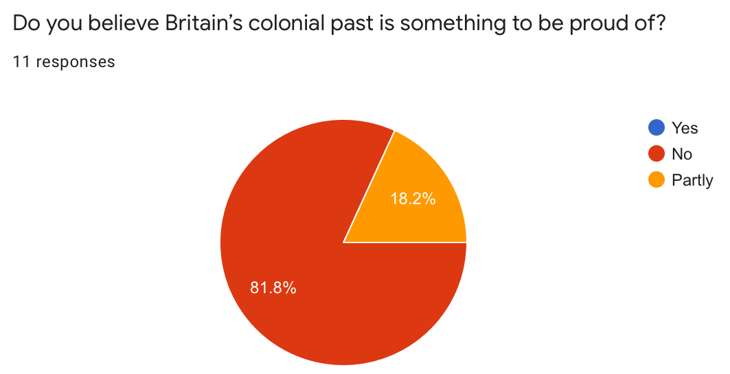
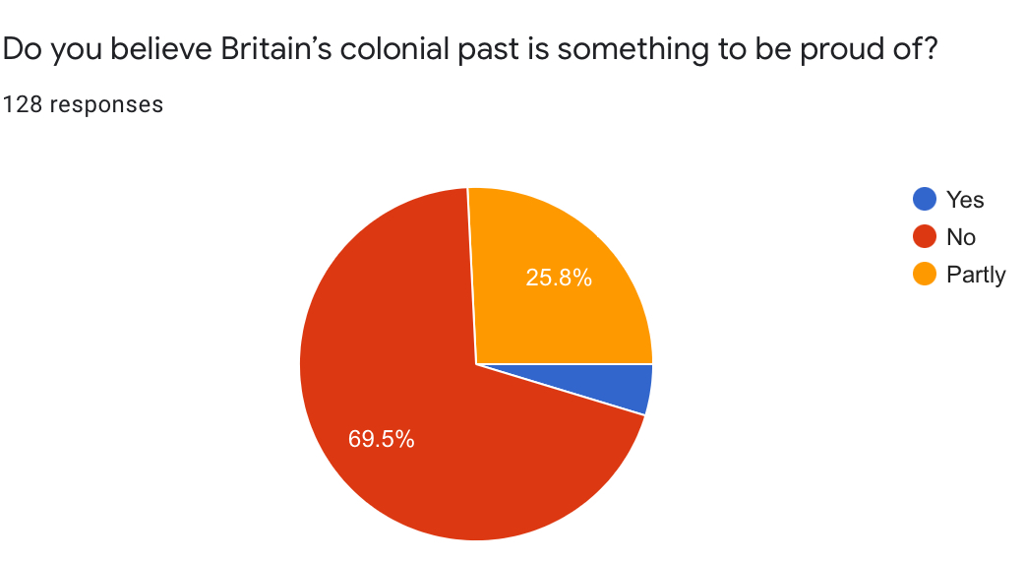
Question: “Do you believe Britain’s colonial past is something to be proud of?”
A level
KS3/4
I asked this question in both surveys, to enable a comparison of the responses. For years 7 to 11, 69.5% of the students believe it is not, whilst 25.8% replied with “Partly”. Whereas 81.8% of History A level students responded with “No”. This is evidence that as students gain more knowledge on the atrocities that the British empire have committed through colonisation, in this case concerning India, they begin to understand further, that our colonial past is not something to be celebrated. However, even the younger students who have not studied the British empire in depth have the overriding, modern and progressive belief that Britain’s colonial past is not something to be proud of. Despite this, there were a few anomalies. For example, in a follow up written question, a KS3/4 student answered “Britain helped evolve India, including transport, army, vaccination and more”.

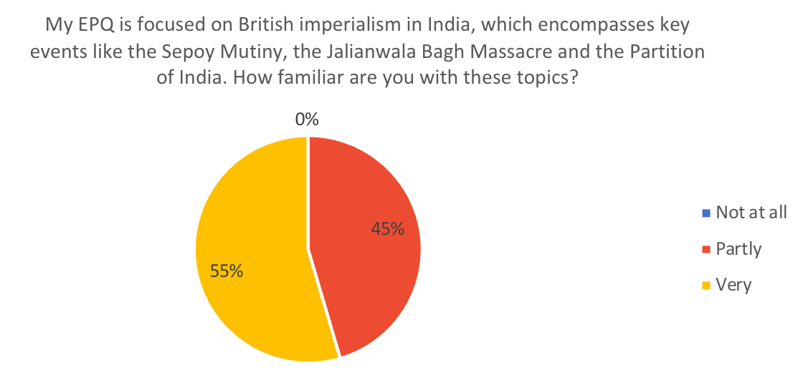
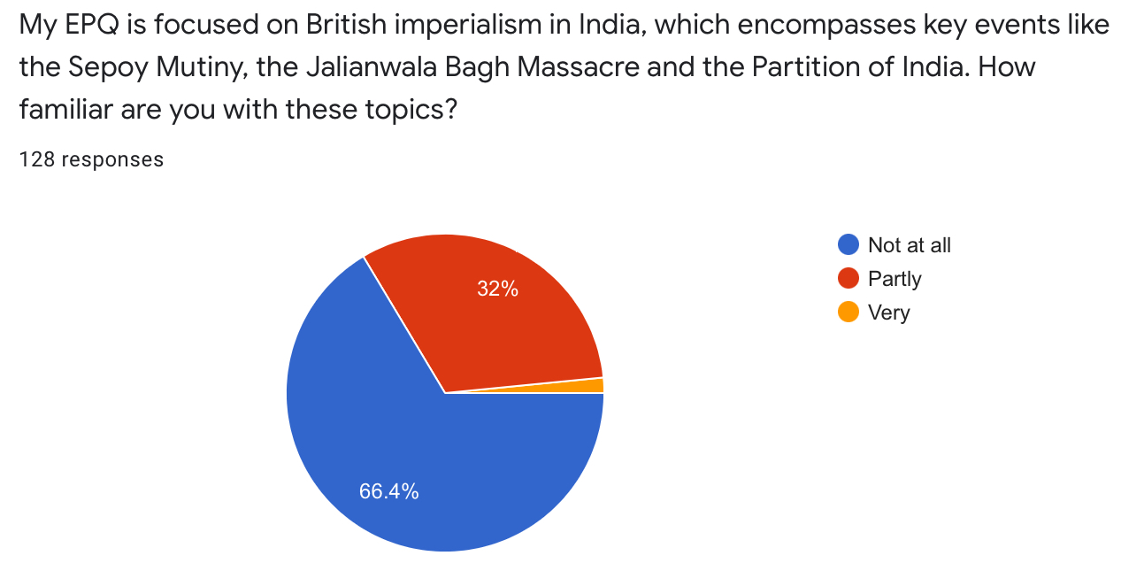
Question: “My EPQ is focused on British imperialism in India, which encompasses key events like the Sepoy Rebellion, the Jalianwala Bagh Massacre and the Partition of India. How familiar are you with these topics?”
A level
KS3/4
11 responses
As displayed above, having not being taught it before, 66.4% of students in KS3/4 did not have any knowledge of key events in the lead up to Indian independence. However, the vast majority of History A level students were very familiar with these events, as expected, since they learn about (most of) them in the course. This supports the idea that the current curriculum is comprehensive and teaches about the main events, but doesn’t answer how balanced this teaching is.

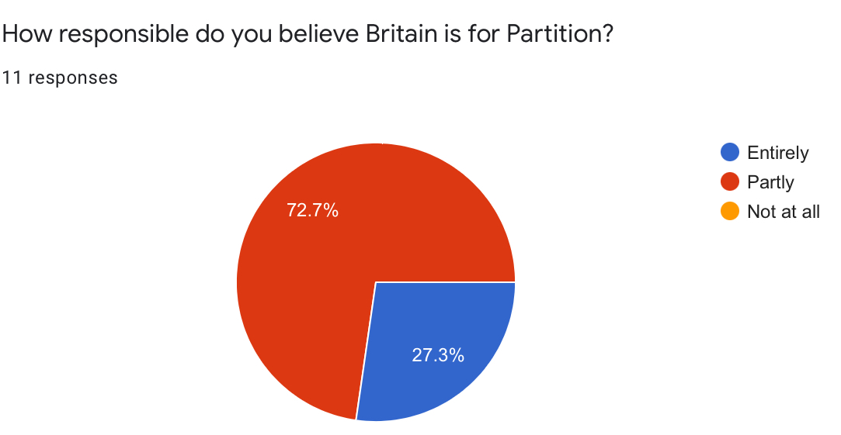
Question: “How responsible do you believe Britain is for Partition?”
A level
I decided to only ask the History students this question, as they are equipped with the necessary factual knowledge to respond adequately. 72.7% believe that Britain was partly responsible, whilst 27.3% believe they were entirely responsible. This supports the idea that the majority of students currently have a balanced view. A student went on to say that Britain’s “policy of divide and rule pitted Muslims and Hindus against each other, creating bitter competition that had not previously existed to such a harsh extent. This then led to the demand for partition.” Another stated that they responded with “Partly” as “religious differences and tension did already exist between groups”.

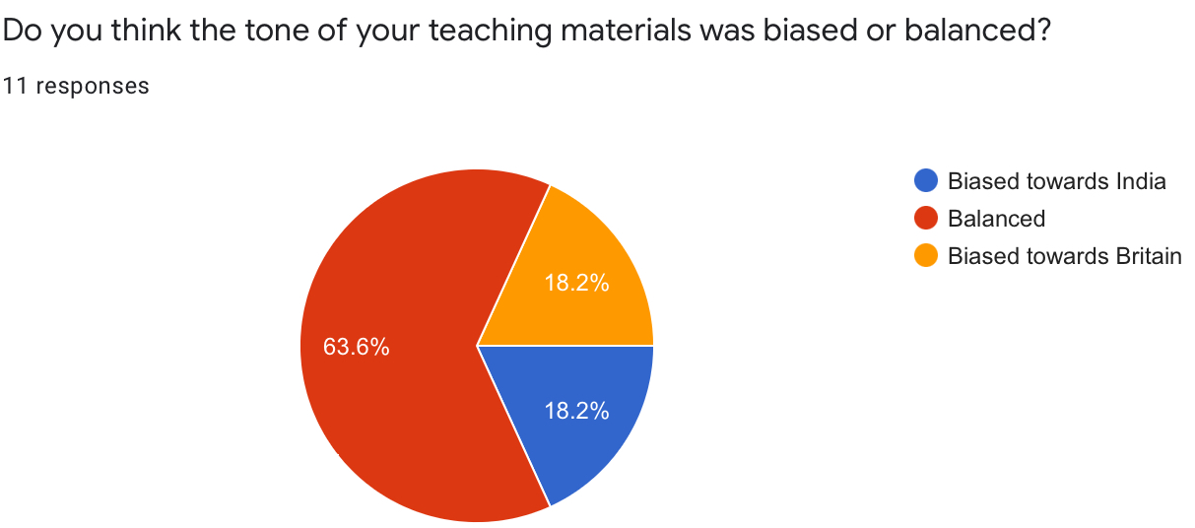
Question: “Do you think the tone of your teaching materials was biased or balanced?”
A level
The penultimate question I asked History A level students provides direct input/answer to my EPQ project title question. 63.6% of students believed that they have been taught in a “Balanced” manner at Putney High School, whilst 18.2% believed the tone of their teaching materials was “Biased towards Britain” and 18.2% believed it was “Biased towards India”. Based on the survey, the majority of students are of the opinion that the topic of the British in India is taught in a balanced manner. This is largely in line with the History A level curriculum, which I have reviewed in detail. I think the key issue here is the manner in which the curriculum is taught, and that the information and the detail within the curriculum, is taught to students in a balanced manner. This will differ from school to school. To improve upon this, I would suggest teachers have regular training and quality control for these lessons.
Although this essay is largely focused on the perspective of students, I did think it was important to gain a further understanding from our teachers’ perspectives. Therefore, as part of my primary research, I interviewed the Head of History at Putney High School, Mr Matthew Pattie. I asked, “What do you think was the most positive aspect of British rule in India?”. Mr Pattie responded “A good cricket team… basically nothing”, after struggling to find an answer. Next, I asked “What do you think was the most negative aspect of British rule in India?”, to which Mr Pattie answered that he believed the Partition of India and Pakistan along religious lines was ill-informed, with a badly planned withdrawal and a legacy that provides much of the modern day tension in India that could have perhaps been avoided. Clearly, Mr Pattie’s views are aligned with those of the students he teaches.

Gaps in the curriculum & an overdue apology
Finally, I researched specific parts of the British rule in India that today’s teaching has omitted and if included, would enrich our learning and provide a more balanced, up to date view of this crucial part of history.
When studying History A-level at Putney High School, we use the Edexcel exam board, which does not provide a “breadth study” of the British Empire, rather only a “depth study”. Although this does vary from exam board to exam board, I did think it was an important point to highlight.
The AS/A Level History textbook, covers India from 1914-48, what they claim to be their “road to independence”. However, I would argue that this excludes key events like the Sepoy Rebellion of 1857, otherwise known as the First War of Independence.
In the Sepoy Rebellion, sepoys refused to use the new rifle cartridges, lubricated with grease containing pig and cows’ lard. In order to serve, the Hindu and Muslim sepoys were required to bite into the cartridges, which they believed was a violation of their religion. Therefore, the army rose up against their British officers representing the East India Company, leading to its dissolution and ultimately the crucial passing of the Government of India Act 1858. This led to the recognition of India’s army, financial system and administration - India was now established as a nation consisting of princely states and British India.
The uprising left a bitter taste in both India and Britain’s mouths of distrust, arguably paving the way forward for the tumultuous relationship between the two countries.
In addition, I would argue that there is a (whether it be subconscious or not) willingness to preserve Churchill’s reputation as a great war hero and leader, and an unwillingness to taint his reputation. For example, the textbook states that “The Bengal Famine was caused by a multiplicity of factors: a run of poor harvests and distribution failures, loss of imports, wartime price inflation and severe weather conditions.” Personally, I believe that Churchill’s decision to divert this food to well-supplied British soldiers and stockpiles, played a major role in the unnecessary deaths of 3 million Indians in 1943. Although it does mention that “Churchill originally refused to divert British merchant shipping in order to take grain to starving Bengal…”, the use of the word “originally” indicates a latter change in his mind, which did not occur. Instead, he went on to say that the “starvation of anyhow underfed Bengalis is less serious than that of sturdy Greeks”. A harsh critic of Churchill, Shashi Tharoor, said during ABC’s Melbourne writers’ festival broadcast, “This is a man the British would have us hail as an apostle of freedom and democracy when he has as much blood on his hands as some of the worst genocidal dictators of the 20th century.” Although this may be an exaggeration, I do believe Churchill’s (negative) role in the Bengal Famine is simply not discussed and emphasised adequately enough. Unfortunately, this means that students must be reliant on their teacher’s unbiased, balanced perspective and in-depth knowledge, to have a well-rounded and just view of British imperialism in India.
Lastly, the (somewhat controversial) topic that I feel should at least be discussed in our learning of the British in India, is that of reparation and apologies. Proponents of reparations (similar to how Germany paid reparations after WW2) argue that after decades of oppression and bloodshed under the British rule, India’s share in the world economy dropped dramatically. Additionally, 2.5 million Indians fought for British forces in the first and second World Wars. Leading economist, Utsa Patnaik, calculated that Britain drained over $45 trillion from India from 1765 to 1938. Although the estimates vary, the point that India has never received reparations, nor apologies, or any form of compensation from Britain since the end of the Raj, is not disputed. As Mr Pattie noted in my earlier interview with him, “Theresa May didn’t apologise for the Amritsar massacre on trips to India.”

This point is highlighted by aforementioned Shashi Tharoor, in his book: ‘Inglorious Empire: What the British Did to India’, and in his (now famous) 2015 Oxford Union speech, through which I discovered him. Tharoor is not a supporter of economic reparations, believing “History, in any case, cannot be reduced to some sort of game of comparing misdeeds in different eras; each period must be judged in itself and for its own successes and transgressions.” Rather he believes that moral atonement and apology would suffice. He discussed the dangers of a sort of “historical amnesia”, where the youth of today in England have a glorified view of the British Empire, and the youth in India don’t understand that the freedoms they take for granted today involved huge struggles and sacrifices by their freedom fighter ancestors 100 years ago. Hence, Tharoor highlights, “It’s important, it seems to me, for both sides to remember.” Personally, I agree with Tharoor on this point. It is impossible (and probably not very beneficial) to place an economic value on the damages the British did to India. Despite this, I do think that an apology would be a crucial component in having a balanced representation of this period of history.

Conclusion

To conclude, I do not believe that students have a balanced view of British imperialism in India. They mostly adopt a negative view on it, but it is a considered opinion, viewing history and evidence through the lens of modern day sensibilities. Students overlay these standards on potentially outdated or unbalanced resources and content. Specifically, in my research, I found that the more positive perceptions of the British rule in India seemed to be more outdated, with recent commentators and the students, focusing on the fact that even if the concept or intention behind colonialism was not immoral, many of the events and actions by the British were.

Furthermore, I have come to the conclusion that the current history syllabi are somewhat limited, relying on the expertise of teachers to provide balance and perspective. Whilst I do believe many teachers are well-equipped to do so, without adequate training, this could result in bias and prejudiced views.

Ultimately, however, I agree with Tharoor – there is not much to be gained by “comparing misdeeds in different eras”, but it is most definitely important that we do not forget these standout events.

Evaluation
During the process of writing this Level 2 EPQ in Y10, I came across a few unexpected difficulties, but overall learnt so much that will be useful and applicable in my everyday/school life.

To begin with, a strength is that throughout my project, I have used a wide range and large number of sources (over 20), including books, textbooks, newspaper articles, academic opinions, and websites. In my research record sheets/literature reviews (attached), I have assessed the credibility of some of the key sources and I do believe that the majority of them have been extracted from well-known, legitimate websites and historians well-versed in this field. In addition, many of the articles I have cited are quite recent, some only being published in 2020/the past couple of years. This demonstrates the relevance and importance of the topic of British imperialism in India, that it is still highly debated today, 75 years on from Indian Independence.

However, a struggle I encountered along the way was effective time management. Personally, I found the workload in Y10 to be significantly higher than what I had in Y9, but still wanted to grasp this opportunity, for a challenge. Whilst I most definitely do not regret it, I do think there were times when I found it difficult to allocate the right amount of time each week to focus on my EPQ, so fell behind my proposed schedule at times (for example, during my end of year exams). I was happy to catch up, but this did mean having to continue working on the EPQ into the start of the summer holidays, when I had hoped to complete it beforehand.

Despite this, a constant motivator for me to continue working hard and complete the project to the best of my ability, was how passionate I am about it. Being of Indian heritage, I was shocked at how little my peers and I knew about the British in India, and how many contradicting perspectives I encountered along the way. Initially, you could say I was a little overwhelmed by the magnitude of information on this topic, much of it extremely opinionated, biased, and made up of misconceptions, that all I really wanted was to focus on the facts, and present a clear, balanced representation of the British in India (whilst including my opinions in small anecdotes at the end of each section).

An issue that I tackled was during the surveying of the students in my school. It was extremely difficult to get even 10 of the History A level students to respond to my questionnaire, as they are quite busy, so I had to send many follow up emails. Their hesitance to respond in contrast with the keenness of the younger years, is a limitation of the statistical analysis.
In addition, whilst I surveyed students and interviewed a teacher, I was unable to speak to any leading historians in the field, which I feel would have improved my project. I did try to get in touch with some, for example, I reached out to Shashi Tharoor’s team. Unfortunately, none were available.
Furthermore, I am a member of Debating club, so it was extremely interesting to be able to incorporate some of the skills I have learnt there, into writing the discussion element of this EPQ. However, I do think that being somewhat opinionated (or argumentative) did pose its own difficulties in some ways. At times, I struggled to push aside my own views (that I had formed throughout my research of the evidence), and write from an unbiased perspective. I found this quite challenging, adding to the point that this topic is one that is quite sensitive to many. This occasionally made it even harder for me to find the right, careful words, as I tried to remain as uncontroversial and unpolitical as possible. I felt as though writing from a balanced, logical perspective would make my project more approachable, digestible, and successful, in terms of my question.

Another limitation I would like to mention is the initial lack of confidence I had in my academic ability. I used to find it extremely difficult not to get bogged down and feel disheartened when reading very long, academic pieces of writing with complicated terminology. Whilst I am still working on it, I truly believe that this EPQ has helped to gain confidence and to select the key, relevant parts of each article, helping me to write in a concise and clear way.

My project aims, set out in my project proposal form (attached), were to 1) review the different ways in which the British rule of India was portrayed around the time of Indian independence 2) assess whether these perspectives were fair, or truly representative 3) compare these views to how the topic of British imperialism in India is taught today 4) explore how or whether these views have changed over time, and if so why 5) investigate any keys areas of the British rule in India that have been omitted from the curriculum today, and discuss if these should be incorporated for a more diverse education. Perhaps not equally, but I am confident that I have succeeded in covering all of these objectives.

In the future, I hope to improve my time management skills, and not underestimate how long I think everything will take, to avoid unnecessary stress. Although I did narrow down my question title once throughout the project, I think going forward I would narrow it down even further and go into even more detail. After narrowing it down once, I found that there was still an overwhelming amount of information and points I was eager to discuss, but couldn’t due to the word count. Perhaps in the future, I would also like to take on a project with more of a scientific focus (for example, something in Psychology), which will enable me to delve deeper into the clinical trial papers cited.

Overall, this EPQ has left me feeling fulfilled, inspired, and as if my knowledge (not just of the topic, but of various skills) has been enriched. Whilst I am aware that a Level 2 EPQ is more focused on research and writing up my findings, with less of a focus on analysis, I feel as though I have learnt some key analytical skills (when analysing the credibility of sources), and other ones such as how to reference. I believe this has prepared me well for the Level 3 EPQ, which I definitely plan to do at A level, and the university style of writing. I also hope to continue studying History at A level, where we do study British India, and I feel prepared and keen to learn even more about it. Finally, my EPQ has inspired me to continue to explore the topics I am interested in and passionate about, outside of school. For example, over the summer I was inspired to take part in an online course by the University of Cambridge – ‘Exploring Law: Studying Law at University’.

Glossary

Imperialism: A system in which one country extends its power and influence by defeating other countries in war, forming colonies, etc.

Colonialism: The practice of gaining control over other countries and occupying them with settlers.

Sepoy: An Indian soldier who served the British.

Anglo-Saxon: A person living in England between the 5th century and the Norman conquest, whose ancestors came from north and west Europe.

Sati/Suttee: A former practice in India whereby a widow threw herself on to her husband's funeral pyre.

Raj: British sovereignty in India.

Divide and rule: The policy of maintaining control over one's subordinates or opponents by encouraging dissent between them, thereby preventing them from uniting in opposition.

East India Company: A trading company formed in 1600 to develop commerce in the newly colonised areas of SE Asia and India. In the 18th century it took administrative control of Bengal and other areas of India, and held it until the British Crown took over in 1858 in the wake of the Indian Mutiny.

Indian Civil Service (ICS): A tiny administrative elite, never more than twelve hundred in number and, until the twentieth century, overwhelmingly British in composition.

Bibliography

Articles

Ann Ewing, Administering India: The Indian Civil Service (London, UK: History Today, 6th June 1982)
https://www.historytoday.com/archive/administering-india-indian-civil-service

Claire Scobie, There’s history between India and Britain (Chennai, Tamil Nadu, India: The Hindu Read, 21st August 2017)
https://www.thehindu.com/thread/reflections/how-india-and-britain-changed-each-other/article19534213.ece

Diya Gupta, Why remembrance of Indian soldiers who fought for the British in World War II is so political (UK: The Conversation, 10th November 2017)
https://theconversation.com/why-remembrance-of-indian-soldiers-who-fought-for-the-british-in-world-war-ii-is-so-political-86885

Ed West, Schools don’t teach about the British Empire – and that’s a good thing (London, UK: UnHerd, 18th February 2020)
https://unherd.com/thepost/schools-dont-teach-about-the-british-empire-and-thats-a-good-thing/

Geoffrey Wheatcroft, Imperial Son (New York, USA: The New York Times, 15th August 2014)
https://www.nytimes.com/2014/08/17/books/review/churchill-and-empire-by-lawrence-james.html

Isaac Chotiner, The Dangerous Idea That British Rule Was Good for India (Brooklyn, N.Y., USA: Slate Magazine, 14th May 2018)
https://slate.com/news-and-politics/2018/05/the-dangerous-idea-that-british-rule-was-good-for-india.html

Manoj Sharma, How much money did Britain take away from India? About $45 trillion in 173 years, says top economist (New Delhi, India: Business Today, 19th November 2018)
https://www.businesstoday.in/latest/economy-politics/story/this-economist-says-britain-took-away-usd-45-trillion-from-india-in-173-years-111689-2018-11-19

Matt, Broomfield, Britons suffer ‘historical amnesia’ over atrocities of their former empire, says author (London, UK: The Independent, 5th March 2017)
https://www.independent.co.uk/news/uk/politics/shashi-tharoor-britain-india-suffer-historical-amnesia-over-atrocities-of-their-former-empire-says-author-a7612086.html

Max Fisher, Was British Colonialism Good or Bad for India? (Washington, D.C., USA: The Atlantic, 17th November 2010)
https://www.theatlantic.com/national/archive/2010/11/was-british-colonialism-good-or-bad-for-india/343366/

Maya Oppenheim, Winston Churchill has as much blood on his hands as the worst genocidal dictators, claims Indian politician (London, UK: The Independent, 8th September 2017)
https://www.independent.co.uk/news/world/world-history/winston-churchill-genocide-dictator-shashi-tharoor-melbourne-writers-festival-a7936141.html

Omer Aziz, Blighted by Empire: What the British Did to India (Los Angeles, USA: Los Angeles Review of Books, 1st September 2018)
https://lareviewofbooks.org/article/blighted-by-empire-what-the-british-did-to-india/

Priya Satia, Why 43% of British still think colonial empire was a good thing, and a source of pride (New Delhi, India: The Print, 24th December 2020)
https://theprint.in/pageturner/excerpt/why-43-of-british-still-think-colonial-empire-was-a-good-thing-and-a-source-of-pride/572651/

The Guardian, India: The British Raj is dead – archive, August 1947 (London, UK: The Guardian, 15th August 2017)
https://www.theguardian.com/world/2017/aug/15/india-pakistan-independence-guardian-editorial-1947?CMP=gu_com#comments

Will Dahlgreen, The British Empire is ‘something to be proud of’ (London, UK: YouGov, 26th July 2014)
https://yougov.co.uk/topics/politics/articles-reports/2014/07/26/britain-proud-its-empire

Websites

https://www.britannica.com/topic/Bengal-famine-of-1943/additional-info#history

https://www.britishempire.me.uk/what-was-the-importance-of-india-to-the-british-empire-.html

https://www.environmentandsociety.org/exhibitions/famines-india/infrastructure-and-railroads

https://webarchive.nationalarchives.gov.uk/ukgwa/20220201210731/https://www.nationalarchives.gov.uk/education/empire/g2/cs4/background.htm

Books

Rosemary Rees et al., Paper 1&2: Searching for rights and freedom in the 20th century (Pearson Education Limited, 2015)

Shashi Tharoor, An Era of Darkness: The British Empire in India (Aleph Book Company, 2016)

Videos

https://www.youtube.com/watch?v=f7CW7S0zxv4

Will Dahlgreen, The British Empire is ‘something to be proud of’ (London, UK: YouGov, 26th July 2014) https://yougov.co.uk/topics/politics/articles-reports/2014/07/26/britain-proud-its-empire
The Guardian, India: The British Raj is dead – archive, August 1947 (London, UK: The Guardian, 15th August 2017) https://www.theguardian.com/world/2017/aug/15/india-pakistan-independence-guardian-editorial-1947?CMP=gu_com#comments
britishempire.me.uk, What was the importance of India to the British Empire? https://www.britishempire.me.uk/what-was-the-importance-of-india-to-the-british-empire-.html
Naresh Chandra Sourabh et al. Infrastructure and railroads (Munich, Germany: Environment & Society Portal, 2015) https://www.environmentandsociety.org/exhibitions/famines-india/infrastructure-and-railroads
Priya Satia, Why 43% of British still think colonial empire was a good thing, and a source of pride (New Delhi, India: The Print, 24th December 2020) https://theprint.in/pageturner/excerpt/why-43-of-british-still-think-colonial-empire-was-a-good-thing-and-a-source-of-pride/572651/
Omer Aziz, Blighted by Empire: What the British Did to India (Los Angeles, USA: Los Angeles Review of Books, 1st September 2018) https://lareviewofbooks.org/article/blighted-by-empire-what-the-british-did-to-india/
Omer Aziz, Los Angeles Review of Books (2018)
Priya Satia, The Print (2020)
Priya Satia, The Print (2020)
Max Fisher, Was British Colonialism Good or Bad for India? (Washington, D.C., USA: The Atlantic, 17th November 2010) https://www.theatlantic.com/national/archive/2010/11/was-british-colonialism-good-or-bad-for-india/343366/
Omer Aziz, Los Angeles Review of Books (2018)
Isaac Chotiner, The Dangerous Idea That British Rule Was Good for India (Brooklyn, N.Y., USA: Slate Magazine, 14th May 2018) https://slate.com/news-and-politics/2018/05/the-dangerous-idea-that-british-rule-was-good-for-india.html
The National Archives, Case Study 4 Background: Living in the British Empire India (London, UK, 1st February 2022) https://webarchive.nationalarchives.gov.uk/ukgwa/20220201210731/https://www.nationalarchives.gov.uk/education/empire/g2/cs4/background.htm
The National Archives (2022)
The National Archives (2022)
The National Archives (2022)
Isaac Chotiner, Slate Magazine (2018)
Isaac Chotiner, Slate Magazine (2018)
Omer Aziz, Los Angeles Review of Books (2018)
Omer Aziz, Los Angeles Review of Books (2018)
Rosemary Rees et al., Paper 1&2: Searching for rights and freedom in the 20th century (Pearson Education Limited, 2015)
Rosemary Rees (2015) page 3
Rosemary Rees (2015) page 246
Fid Backhouse et al., Bengal famine of 1943 (Chicago, Illinois, USA: Encyclopaedia Britannica, 9th June 2022) https://www.britannica.com/topic/Bengal-famine-of-1943/additional-info#history
Rosemary Rees (2015) page 246
Geoffrey Wheatcroft, Imperial Son (New York, USA: The New York Times, 15th August 2014) https://www.nytimes.com/2014/08/17/books/review/churchill-and-empire-by-lawrence-james.html
Maya Oppenheim, Winston Churchill has as much blood on his hands as the worst genocidal dictators, claims Indian politician (London, UK: The Independent, 8th September 2017) https://www.independent.co.uk/news/world/world-history/winston-churchill-genocide-dictator-shashi-tharoor-melbourne-writers-festival-a7936141.html
Diya Gupta, Why remembrance of Indian soldiers who fought for the British in World War II is so political (UK: The Conversation, 10th November 2017) https://theconversation.com/why-remembrance-of-indian-soldiers-who-fought-for-the-british-in-world-war-ii-is-so-political-86885
Manoj Sharma, How much money did Britain take away from India? About $45 trillion in 173 years, says top economist (New Delhi, India: Business Today, 19th November 2018) https://www.businesstoday.in/latest/economy-politics/story/this-economist-says-britain-took-away-usd-45-trillion-from-india-in-173-years-111689-2018-11-19
https://www.youtube.com/watch?v=f7CW7S0zxv4
Shashi Tharoor, An Era of Darkness: The British Empire in India (Aleph Book Company, 2016) page xxi
Matt, Broomfield, Britons suffer ‘historical amnesia’ over atrocities of their former empire, says author (London, UK: The Independent, 5th March 2017) https://www.independent.co.uk/news/uk/politics/shashi-tharoor-britain-india-suffer-historical-amnesia-over-atrocities-of-their-former-empire-says-author-a7612086.html
Isaac Chotiner, Slate Magazine (2018)
Shashi Tharoor (2016) page xxi
https://www.futurelearn.com/courses/exploring-law-studying-law-at-university
Maurice Waite, Oxford Paperback Dictionary and Thesaurus (Oxford University Press, 2001) page 464
Maurice Waite (2001) page 168
Maurice Waite (2001) page 843
Maurice Waite (2001) page 33
Oxford English Dictionary, Oxford Languages (Oxford UK: Oxford University Press, 1989)
Oxford English Dictionary, Oxford Languages (1989)
Oxford English Dictionary, Oxford Languages (1989)
Oxford English Dictionary, Oxford Languages (1989)
Ann Ewing, Administering India: The Indian Civil Service (London, UK: History Today, 6th June 1982) https://www.historytoday.com/archive/administering-india-indian-civil-service

